How often will my care plan be reviewed?
This varies from person to person; it should be reviewed at least once a year, but more frequently if you, your doctor or nurse agree that this is needed.

What if I do not want a care plan?
Many people with (a) long term condition(s) feel confident about managing them and prefer to get on with their lives as independently as they can.
You might not want a care plan, which is fine, but you should still have a regular discussion with your doctor, nurse or other health or social care professional about how you are managing your condition(s), and what you can do for yourself.
You should also be listened to with your views taken into account and be given any new information that would be helpful.

For more useful information, speak to your GP or nurse.
Named Health professional:
………………………………………………….
Contact Number: …………………………..
Date March 2015


Useful links
xxxxxxxxxx

Or another picture?

If you need this leaflet in a different language, audio, large print or braille please email us on sheccg.comms@nhs.net or call 0114 305 1212.
www.sheffieldccg.nhs.uk
/SheffieldCCG
@NHSSheffieldCCG






Person Centred Care Planning


The Benefits of Person centred Care
Delivering better services for people with long term conditions



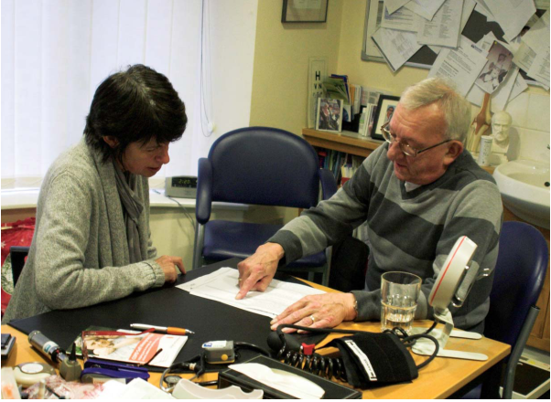

What is Person centred care?
We think you are the most important person in deciding what matters in your health care. Health care professionals should work with you as an equal partner. They will seek to understand you and your carers and to give you a say in your care. They will bring together services to achieve the outcomes which are important to you. Person centred care planning puts patients and their families at the heart of all decisions.
What are long term conditions?
Long term conditions are conditions that you may live with every day. These are some of the most common ones: Diabetes, Heart Disease, Lung disease, Mental health problems, Asthma, Epilepsy but there are many others. You may have one or more of these conditions.
Preparing for your appointment
Before your appointment, you may wish to think about what it is important for you to discuss and any questions you would like to ask.. You can take someone with you to your appointment, and you may want to discuss what you’d like to say with that person . Doing this often helps you get the most out of your time at the appointment

Your Care Plan
Your appointment will be for longer than normal. You may get your results and other information before your appointment so you can think about what you want to discuss. After your care plan discussion you may want to agree on a personalised action plan. This will be your care plan, which includes what you want to do yourself, and the support to help you do it.
This is where the term ‘self-care’ might be used. Other details it could include are the services you will be receiving and a date when the plan will be reviewed. It may include information about your condition(s) treatment and contact details for support services such as self-help groups.

How can a person centred care plan help you?
Agreeing a care plan with your doctor or practice nurse means being able to talk about:
- Your condition(s)
- How your health problems affect your life
- What you want to do
- What more you can do for yourself with the right support
This will help you to manage better and keep your condition(s) under control. It is about being given all the information you need, being listened to, being able to ask questions about your condition(s) and feeling able to say what is really important to you.
This will help to ensure that you get the right services and that you know about the wider choices available to meet all your needs, not just the medical ones. It will also help you to have a clear understanding of your medical condition(s) and the impact this may have on your life.
What does self-care mean?
We all self-care every day without realising it; for example, taking medicines properly and eating well. You can improve your quality of life by making some small lifestyle changes. This is where self-care may be used. Managing your condition better will help you keep well for longer. Whatever you decide, your care planning discussion should help to support you with your self-care.

